 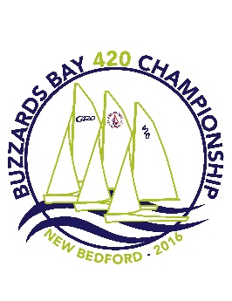 

Buzzards Bay 420 Championship

Host, Organizing Authority: Community Boating Center

Location: Fort Taber, New Bedford, MA

Racing Venue: Waters Immediately off of Fort Taber, New Bedford, MA

**420 SAILING INSTRUCTIONS**

1. **RULES**
   1. The regatta will be governed by the rules as defined in *The Racing Rules of Sailing* (RRS).
   2. Attachments and supplements are part of these sailing instructions.
   3. No contestant shall use, either on or off the water, alcoholic beverages (beer, wine or distilled spirits) or use any controlled substance (marijuana, cocaine, etc) the possession of which is unlawful. This prohibition is in effect during the entire event, from date and time of arrival through date and time of departure from the Fort Taber. Penalties for a violation of the prohibition may range from a reprimand to dismissal from the regatta. A hearing may be held in accordance with the RRS.
2. **ENTRY PROCEDURES**
   1. Boats that race before completing the entry procedures described in the NOR will be scored Did Not Compete for such races, without a hearing. This changes RRS 63.1, A4.1 and A5.
3. **NOTICES TO COMPETITORS**
   1. Notices to competitors will be posted on the official notice board located inside the CBC Stucco building
4. **CHANGES TO SAILING INSTRUCTIONS**
   1. Any changes to the Sailing Instructions will be posted before 0830 on the day they will take effect, except that any change in the schedule of races will be posted by 1900 on the day before it will take effect.
5. **SIGNALS MADE ASHORE**
   1. Signals made ashore will be displayed from the LTYC flagpole.
   2. When flag AP is displayed ashore, ‘1 minute’ is replaced with ‘not less than 60 minutes in race signal AP. This changes Race Signal AP.
6. **SCHEDULE OF RACES**
   1. The scheduled time of the warning signal for the first race each day is 1030.
   2. Subsequent races will be held as soon as practicable after the end of the previous race. If the race committee intends to start another race on the same day, it will display the Second Substitute (with no sound) while boats are finishing.
   3. The race committee will run as many races as practicable each day.
   4. No warning signal for the first fleet will be made after 1400 hours on Sunday.
   5. Flag A displayed, with no sound, while boats are finishing means, “No more racing today”.
   6. Schedule

**Thursday 8/4/2016**

1500 – 2000 Arrival and On-site Check-in & sail number verification

**Friday 8/5/2016**

0700 – 0830 On-site check-in & sail number verification

0845 - Mandatory coach, parent, support boat meeting

0900 – Mandatory competitors meeting

0930 – Harbor Start – Pink Streamer Fleet launches first, Blue streamer second. Green fleet, if three fleets are required, launches third.

1030 – First warning signal

Immediately upon returning to shore – Post racing check-in

Ice Cream social on shore following racing

**Saturday 8/6/2016**

0930 – Harbor Start – Fleet launching order, if any, will be announced at launch area.

1030 – First warning signal

Immediately upon returning to shore – Post racing check-in

Pizza Party on shore following racing

**Sunday 8/7/2016**

0930 – Harbor Start – Fleet launching order, if any, will be announced at launch area.

1030 – First warning signal

Immediately upon returning to shore – Post racing check-in

No warning signal for the first fleet will be made after 1400 hours

Awards ceremony ASAP following racing

**\* Lunch will not be provided during the event. Please provide your own**

1. **RACING AREA**

C420s will race in the waters immediately off Fort Taber, New Bedford, MA. See attached racing area picture (*NOT for Navigational purposes*). Be aware of commercial and seasonal traffic east of Fort Taber.

1. **COURSES**
   1. The diagrams in Attachments 1, 2, and 3 show the course configurations.
   2. Marks, including the windward offset mark shall be rounded in order and left to port, except that a leeward gate shall be rounded as described in RRS 28.2(c). If only one leeward mark is set, it shall be rounded to port.
   3. The courses will be:

TO Outer Trapezoid: Start-1(port)-offset (port)-2(port)-3S/3P(gate)-2(port)-3(port)-Finish

TI Inner Trapezoid: Start-1(port)-offset (port)-5S/5P(gate)-1(port)-offset(port)-2(port)-3(port)-Finish

TOW Outer Trapezoid Windward Finish: Start-1(port)-offset (port)-2(port)-3S/3P(gate)-2(port)-3(port)-4(port)-Finish

TIW Inner Trapezoid Windward Finish: Start-1(port)-offset (port)-5S/5P(gate)-1(port)-offset(port)-2(port)-3(port)-4(port)-Finish

WO Windward/Leeward, posted with the number of full legs; e.g.,

WO3: Start-1(port)-offset (port)-5(port)-Finish (upwind)

WO5: Start-1(port)-offset (port)-5(port)-1(port)-offset (port)-5(port)-Finish(upwind)

WOG Windward/Leeward with a leeward gate, posted with the number of full legs; e.g., WOG3: Start-1(port)-offset (port)-5S/5P(gate)-Finish (upwind)

WOG5: Start-1(port)-offset (port)-5S/5P(gate)-1(port)-offset (port)-5S/5P(gate)-Finish(upwind)

NOG Windward/Leeward with the leeward mark and finish set to leeward of signal boat; e.g.,

NOG3: Start-1(port)-offset (port)-4S/4P(gate)-Finish(upwind)

* 1. The following information will be displayed on a board on the RC signal boat:

• The course designation;

• The approximate distance (in nautical miles) from the starting line to mark 1;

• The approximate compass bearing from the starting line to mark 1.

For example:

TI

1.0

235

* 1. After starting, competitors shall not cross the starting or finishing lines except when complying with a rule or, after finishing, refinishing. The starting and finishing lines are obstructions on all legs of the course (including a leg starting a second lap) except on the first and last legs.

1. **MARKS**
   1. The marks are as follows; All marks used will be inflatable marks. When an offset mark is used it shall always be observed. Leeward marks may be gates.
2. **THE START**
   1. Before racing each day each boat shall check in with the signal boat by passing behind the signal boat from the starboard side on starboard tack and shall hail her sail number until acknowledged by the race committee. Boats that fail to check in before their Preparatory signal may receive a 20% scoring penalty [see RRS 44.3(c)] without a hearing. This changes RRS 63.1 and A5.
   2. Class flags and time limits (See SI 14) are described in the table below.

|  |  |  |  |  |
| --- | --- | --- | --- | --- |
| Color | **Class** | **Class Flag** | **Time Limit (minutes)** | **Finishing**  **Window**  **(minutes)** |
| Green | Club 420 | Group Color | 90 | 30 |

* 1. The starting line will consist of 2 line segments, which will be between the staffs on race committee boat(s) from which orange flags are displayed. The signal boat will be the starboard end of the line. The pin (port end) may be a boat or a mark (see Attachment 3-Mark Descriptions). The mid-line mark may be a boat or a mark (see Attachment 3- Mark Descriptions). The race committee may add a second mid-line mark or boat, in which case the starting line will consist of 3 line segments.
  2. The race committee may deploy a “keep off” buoy, temporarily attached to the signal boat.
  3. A boat starting later than 4 minutes after her starting signal will be scored Did Not Start without a hearing. This changes RRS 63.1, A4.1 and A5.

1. **RECALLS**
   1. The race committee may attempt, after the starting signal, to hail the sail numbers of OCS boats and boats that must comply with RRS 30.1. This changes RRS 29.1 and 30.1.
   2. When RRS 30.1 is in effect, the race committee may, in the last minute before the starting signal, hail the sail numbers of boats that have any part of the boat, crew or equipment on the course side of the starting line.
   3. The failure of a boat to hear the hail, the hail of some but not all OCS boats, or the untimely hail of some or all OCS boats shall not be grounds for granting redress. This changes RRS 62.1(a).
   4. Rule 30.1 is replaced with: “If flag I has been displayed, and any part of a boat’s hull, crew or equipment is on the course side of the starting line or one of its extensions during the last minute before her starting signal, she shall thereafter either (a) sail from the course side across an extension of the starting line beyond either the port- or starboard-end line boat to the pre-course side before *starting* or (b) round a mid-line starting boat before starting, leaving it to port (see the diagram below).

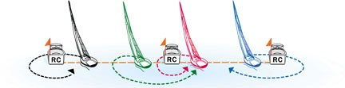

1. **CHANGE OF THE NEXT LEG OF THE COURSE**
   1. To change the position of the next mark, the race committee will move the original mark.
2. **THE FINISH**
   1. The finish line will be between a staff displaying an orange flag on a race committee boat and the course side of the finish mark.
3. **TIME LIMIT**
   1. The time limits are shown in SI 10.2.
   2. A "finishing window" will open when the first boat that sails the course finishes. Boats still racing when the finishing window closes (see SI 10.2) will be scored “Time Limit Expired” without a hearing. This changes RRS 35, 63.1, A4.1 and A5. Time Limit Expired is defined as one place more than the number of boats who properly sailed the course and finished in the finishing window.
   3. If boats at the end of the fleet are delaying the start of another race, the race committee may terminate the race and score those boats in the places they would have finished. This changes RRS A4.
4. **PENALTIES WHILE RACING**
   1. The Two-Turns Penalty of rule 44.2 will apply.
5. **POST RACE PENALTIES**
   1. Appendix T of the RRS, Section B applies. A post-race scoring penalty of 20% or 30% may be taken after informing the race committee in writing within the prescribed protest time limits.

1. **PROTESTS, REDRESS AND ARBITRATION**
   1. Protest forms will be available at the protest desk in the LTYC clubhouse.
   2. Requests for scoring review (including OCS) shall be filed within the protest time limit on forms available at the protest desk. Such requests will be reviewed by the race committee before being scheduled for hearing by a protest committee. If unresolved, they shall be considered a Request for Redress and will be considered to have met the protest time limit. This changes RRS 63.1.
   3. Protests shall be delivered to the protest desk within 60 minutes after the race committee finish boat docks. The protest time limit will be posted on the official notice board.
   4. A list of protests will be posted on the official notice board within 20 minutes of the end of protest time. This posting constitutes the notification required by RRS 61.1(b) and 63.2.
   5. Boats are not permitted to protest alleging a breach of SI 18 or 19. This changes RRS 60.1(a). Penalties for these breaches may be less than disqualification if the protest committee so decides.
   6. A boat intending to protest alleging a breach of a rule of Part 2 should report her intention, including the sail number(s) of the boat(s) she intends to protest, to the RC aboard the finish boat as soon as possible after finishing.
   7. Appendix T of the RRS, Section D “Arbitration” applies.
   8. All competitors and support personnel shall comply with the parking, launching and hauling, and support boat regulations, and shall comply with reasonable requests from regatta officials. The protest committee may, at its discretion, assess a penalty after a hearing for breaches of this rule, including dismissal from the event.
2. **SCORING**
   1. The Low Point scoring system of RRS Appendix A will apply, changed so that each boat’s series score will be the total of her race scores with her worst score excluded only if five (5) or more races have been completed.
   2. Format: See c420 Racing Format – Supplement to the Sailing Instructions attached
   3. A boat racing with any sail number different from the number on her entry form (or sail number change form) will be scored Did Not Compete without a hearing. This changes RRS 63.1, A 4.1, A5 and G4.
   4. For Friday and Saturday, only races completed by both the Yellow and Blue groups will be included in the series scoring.
3. **SAFETY REGULATIONS**
   1. All competitors shall wear, while on the water (other than for brief periods while adding or removing clothing), a properly fastened US Coast Guard approved (or the equivalent authority of the competitor’s home country) PFD. This changes the US Sailing Prescription to RRS 40.
   2. A boat retiring from a race shall notify a race committee vessel before leaving the racing area, or, when that is impossible, the LTYC office immediately after arriving ashore.
   3. If the race committee displays flag L before the Warning signal to indicate that a check-in is required, boats that fail to check in before their Preparatory signal may receive a 20% scoring penalty [see RRS 44.3(c)] without a hearing. This changes RRS 63.1 and A5.
   4. Any boat receiving ‘hands on’ assistance from any support boat will be scored Did Not Finish without a hearing. This changes RRS 63.1, A4.2 and A5. The race committee may decide when a boat or crew needs assistance.
   5. If there is a medical emergency, contact any RC vessel, or call the EMT boat (VHF channel 5A)
4. **TRASH DISPOSAL**
   1. Boats shall not put trash in the water. Trash may be placed aboard support and race committee boats. The penalty for breaking this rule will be at the discretion of the protest committee and may include adding points to a boat’s score in the race or the series. This changes RRS 55.
5. **General Coach boat and spectator boat requirements**
   1. Coach boats shall carry a working VHF radio and monitor the race committee channel. Coach boats and spectator boats must register prior to the first competitors’ meeting on the first day of racing with the Organizing Authority (OA) and fly a flag as directed by the OA (a $20 cash deposit will be required) at all times while on the water. Coaches and spectators shall stay outside areas where boats are racing during racing. Coach and spectator boats shall follow the instructions of race committee. Coach boats are responsible for helping all boats in distress.

Coach boats and spectator boats may enter the racing area during a race for safety reasons when rendering assistance to a boat in distress. When entering the racing area for safety reasons, a boat must notify the Race Committee of her action. All coach boats shall stay more than 50 yards away from any racing boat, and at least 50 yards outside the racing area – especially marks of the course, whichever is greater, and move slowly and with minimal wake. All spectator boats shall stay more than 75 yards away from any racing boat, and at least 75 yards outside the racing area, whichever is greater, and move slowly and with minimal wake. All coach boats and spectator boats shall stay out of the starting area at all times.

* 1. Coach and spectator boats shall stay more than 100 yards off the beaches at all times unless there are safety reasons.
  2. Coach and spectator boats that violate SI 21 may be subject to disciplinary actions up to and including exclusion from the venue.

**22 PRIZES**

21.1 Prizes will be given as described in the NOR.

**ATTACHMENTS:**

1: Trapezoid with reaching finish course diagrams

2: Trapezoid with windward finish course diagrams

3: Additional course diagrams

4: Race Area

5: Launching and support boat keep away area

**C420 RACING FORMAT: SUPPLEMENT TO THE SAILING INSTRUCTIONS**

## Gold and Silver

There will be a Qualifying Round followed by a Medal Round. The Qualifying Round will be used to split the fleet placing about the top 50% into the Gold Fleet and the remainder into the Silver Fleet for the Medal Round. There will be a determined number of divisions of approximately the same size in the Qualifying Round.

However, in the Medal Round there will only be one division of the Gold Fleet and one division of the Silver Fleet. A minimum of 5 races per division is required to complete the Qualifying Round. If five races are not sailed before the start of the last day of the Championship, then the Medal Round will not be sailed.

Competitors will only sail in their assigned division each day.

Procedure for Division Assignments

a)     Day One:  Assignment to a division for the first day of racing will be a combination of ‘seeding’ by final standings seeded by class Executive director and by geographical assignment for competitors who did not attend.

b)     Day Two:  The results of Day One seeded 1-2-2-1-1-2-2-1, et cetera.

c)     Day Three:  If still in the Qualifying Round, will be the same formula based on the current standings in the regatta.

d)     If no racing from the day before, then the day before divisions will be used for the current day of racing. However, if 5 races per division have been completed, then the divisions go to the Medal Round.

e)     The Race Committee’s decision on division assignments will be final and cannot be grounds for redress. This changes RRS 62.1(a).

Medal Round

a)     Gold and Silver fleets will race as single divisions.

b)     Assignment to the Gold and Silver Fleets will be based on a competitor’s cumulative fleet position at the end of the Qualifying Round, including the outcome of all scoring inquiries, requests for redress and protests. Assignment to each fleet will be for the entire Medal Round.

c)     Scores from the Qualifying Round will carryover, including any drops.

d)     A boat’s cumulative score for the Medal Round will be boat’s total score from the Qualifying Round plus her total score from the Medal Round including 1(one) drop.

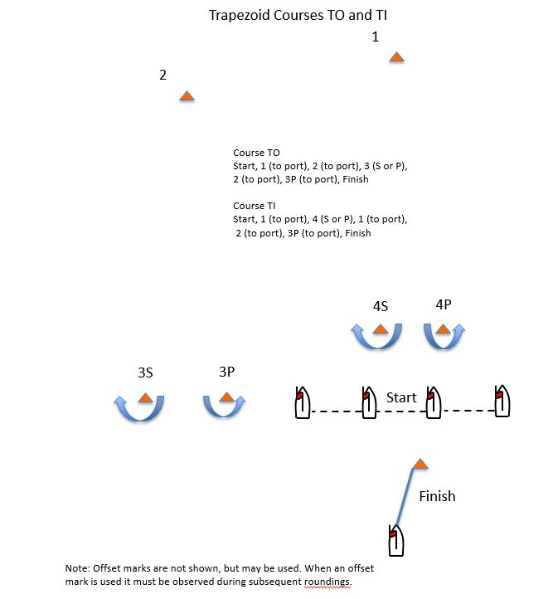

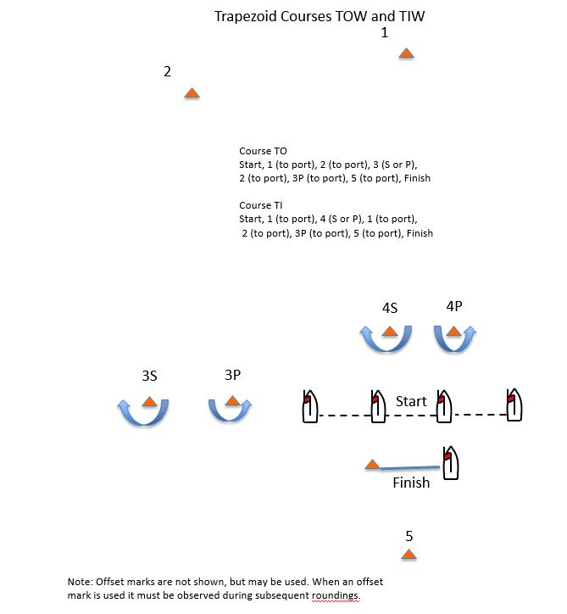

**Additional Course Diagrams**

NOG3WO3WOG3

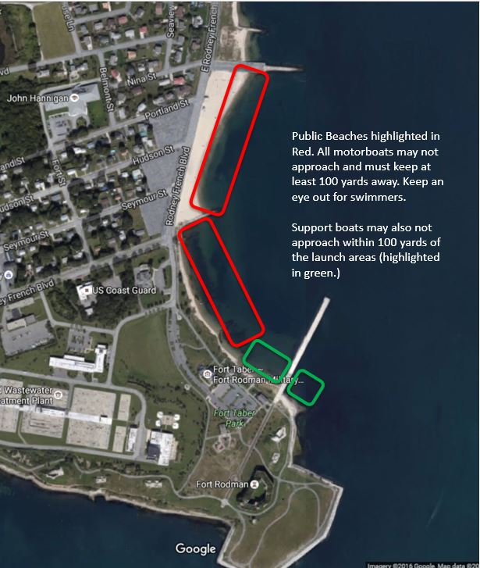

Revised 8/1/2016