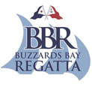
45th Annual
BUZZARDS BAY REGATTA
August 3, 4, and 5, 2018

AMENDMENT 3 TO THE SAILING INSTRUCTIONS

Add to Attachment 4 “Possible Buoy Locations for the Dick Fontaine Memorial Race”:

Mark “Nye” is green bell “G1”at Nye Ledge (41º 37.065’N; 070 º 46.171W)

Posted 8/03 1130

