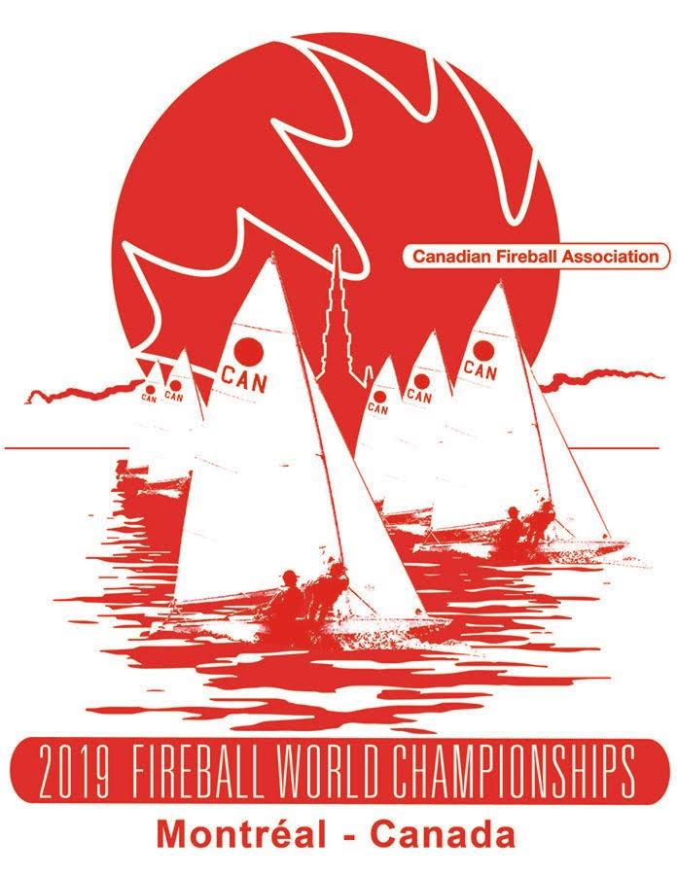
International Fireball North American and World Championship
August 20-30, 2019

Montreal, Quebec, Canada

Organised by Pointe Claire Yacht Club in conjunction with Fireball International,
the Canadian Fireball Association and the Quebec Fireball Association.

Notice of Race

The notation ‘[DP]’ in a rule in the NOR means that the penalty for a breach of that rule may, at the discretion of the international jury, be less than disqualification.

Rules
  - The regatta will be governed by the rules as defined in The Racing Rules of Sailing.
  - The Sail Canada prescriptions which apply are listed in Attachment A.
  - The RRS Appendix G3 is changed to allow loaned or chartered boats to use a sail number different from the hull number, providing it is not the sail number of any other boat in the regatta.
  - Insert new rule 42.3(i): When the wind speed is clearly over 12 knots across the course, the Race Committee may signal in accordance with RRS Appendix P5 that pumping, rocking and ooching are permitted after the starting signal. This changes RRS 42.2(a), 42.2(b) and 42.2(c).
  - RRS Appendix P2.3 shall not apply and P2.2 is changed so that it will apply to all penalties after the first one.
  - If there is a conflict between languages the English text will take precedence.

Advertising [DP]
Boats may be required to display advertising chosen and supplied by the organizing authority.

ELIGIBILITY AND ENTRY
  - The regatta is open to all boats of the International Fireball class whose helmsman and crew are affiliated or unaffiliated members of Fireball International.
  - Eligible boats may enter on line: for the North American Championship at: https://yachtscoring.com/emenu.cfm?eID=6009
and for the World Championship at:
https://yachtscoring.com/emenu.cfm?eID=6010
or
By completing the form(s) in attachment C and sending them, together with the required fee, to Quebec Fireball Association at 128 Ave de Bathurst, Pointe-Claire, QC, H9S 4Z8, Canada no later than June 30, 2019. Please make your Canadian Dollar Cheque or money order payable to the Quebec Fireball Association.
  - Late entries will be accepted until August 20, 2019 and will be subject to a late registration fee of CAD $150.

Fees
Required fees are as follows:
Event Fee
North Americans CAD $200
World Championship CAD $700
Combined CAD $800
Tickets for social events and dinners will be available for purchase for non-competitors.

Schedule
5.1 Registration:
Tuesday, August 20 from 13h00 to 16h00
Wednesday, August 21 from 10h00 to 14h00
Saturday, August 24 from 10h00 to 14h00

5.2 Equipment inspection and event measurement:
Tuesday, August 20 from 10h00 to 17h00
Saturday, August 24 from 10h00 to 17h00

5.3 Racing Schedule:
Fireball North American Championship
Day | Date | Races
Wednesday | August 21, 2019 | 2
Thursday | August 22, 2019 | 2
Friday | August 23, 2019 | 2

Fireball World Championship
Day | Date | Races
Sunday | August 25, 2019 | 2
Monday | August 26, 2019 | 2
Tuesday | August 27, 2019 | 2
Wednesday | August 28, 2019 | No Racing
Thursday | August 29, 2019 | 2
Friday | August 30, 2019 | 2

The scheduled time of the warning signal for the first race each day is 13h00 except Friday, August 30 when the scheduled time is 11h00. One additional race per day may be added at the discretion of the race committee. There will be a maximum of 6 races for the North American championships and a maximum of 10 races for the World championships.

5.4 On the last scheduled day of racing no warning signal will be made after 15h00.

Measurement
  - Each boat shall produce a valid measurement certificate. All boats and equipment shall be presented for pre-event inspection. Detailed instructions will be provided at registration.
  - Classic Boats will be identified during the measurement inspection. A list of classic boats by sail number will be published on the official notice board prior to the first race of the World Championship.

Sailing Instructions
The sailing instructions will be available at registration.

Venue
Attachment B shows the location of the regatta harbour and the location of the racing area.

The Courses
The courses to be sailed will be described in the Sailing Instructions.

Penalty System
Decisions of the international jury will be final as provided in RRS 70.5.

Scoring
  - Three races are required to be completed to constitute a series.
  - When fewer than 5 races have been completed, a boat’s series score will be the total of her race scores.
  - When from 5 to 8 races have been completed, a boat’s series score will be the total of her race scores excluding her worst score.
  - When 9 or more races have been completed, a boat’s series score will be the total of her race scores excluding her two worst scores.

Support Boats
All drivers of support boats shall be registered with the organizing authority and will be required to comply with event support boat regulations. [DP]

Berthing
Boats shall be kept in their assigned places while they are in the boat park. [DP]
- RIGHT TO USE NAME AND LIKENESS
By participating in these Championships, each competitor automatically grants to the organizing authority and its sponsors the right in perpetuity to make, use and show, from time to time and at their discretion, photographs and motion pictures, and live, taped or filmed television and other reproductions of him or her during the competition, without compensation.

Prizes
Prizes will be awarded for the North American Championship.
Prizes will be given as follows for the World Championship:
Race 1 Moore Trophy
Race 2 Rondar Cup
Race 3 Volvo Trophy
Race 4 Certina Trophy
Race 5 Mildara Wines Trophy
Race 6 Bell Bowl
Race 7 Sponsor Trophy
Race 8 RVYC Trophy
Race 9 Safaricom Kenya Trophy
Race 10 P & B Trophy
Overall Crew Humboldt Trophy
Overall Worlds Worlds Trophy
Overall Classic Classic Boat Trophy
Woman Thelassa Trophy
Perseverance Geest Trophy

Other prizes may be awarded.

- DISCLAIMER OF LIABILITY
Competitors participate in the regatta entirely at their own risk. See RRS 4, Decision to Race. The organizing authority will not accept any liability for material damage or personal injury or death sustained in conjunction with or prior to, during, or after the regatta.
- INSURANCE
Each participating boat shall be insured with valid third-party liability insurance with a minimum cover of CDN $1,000,000 per incident or the equivalent.
- ACCOMODATION
A wide range of accommodation is available. A limited number of billets are being provided on a first come first served basis. Camping may be permitted in the park adjacent to the yacht club.

19 FURTHER INFORMATION
For further information please contact info@fireballworlds2019.org.
Canadian Fireball Association: President@fireball-international.ca.
Fireball Quebec: Quebec@fireball-international.ca
Pointe Claire Yacht Club: pcycoffice@pcyc.qc.ca

Attachment A

Sail Canada Prescriptions in effect:
Rule 61.2 – Protest Contents Sail Canada prescribes that no fee shall be charged for delivering a protest or a request for redress.
Rule 67 – Damages Sail Canada prescribes that a boat that has been found by a protest committee to have broken a rule and caused damage shall be considered at fault for the purposes of rule 67.
Rule 91(b) – Protest Committee Sail Canada prescribes that a request for an international jury formed under rule N1.7 comprised of only three members requires written approval be obtained from Sail Canada before making the request to World Sailing.

Attachment B

The address of Pointe-Claire Yacht Club which is approximately 27km West of downtown Montreal and 10km West of Dorval Airport (YUL) is:

Pointe-Claire Yacht Club
1 Avenue Cartier
Pointe-Claire, QC
H9S 4R3
Canada

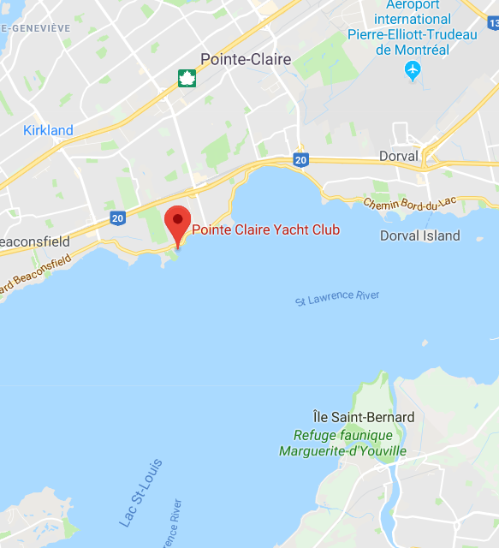

Attachment C
Entry Form: North American Championships
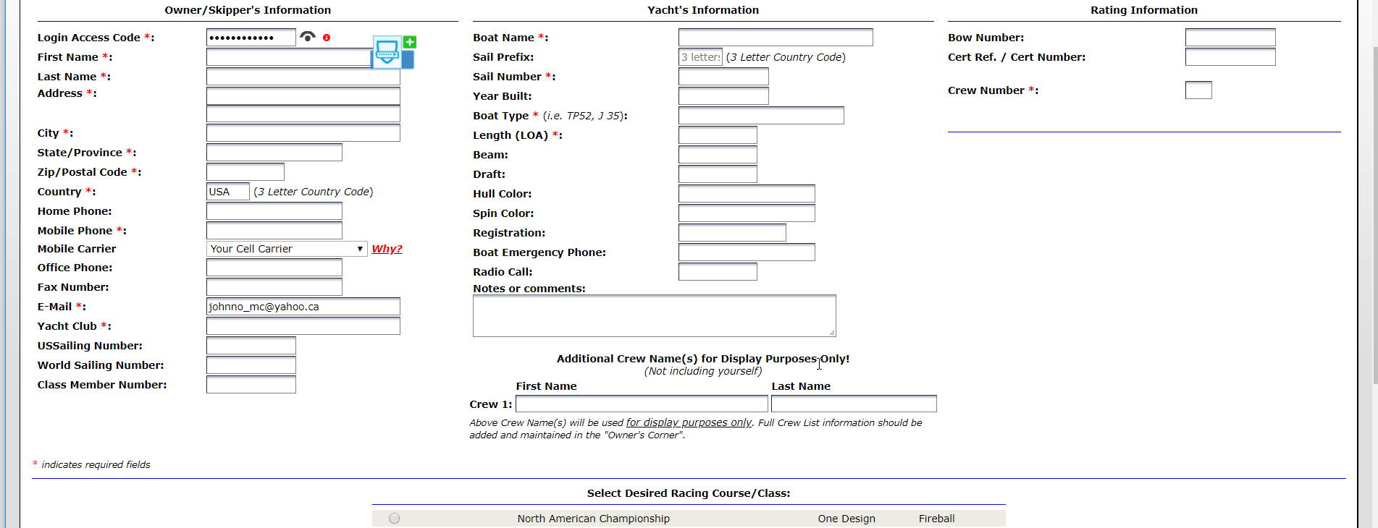

Entry form 2019 Fireball World Championship
